<https://www.gardeningcollective.com/water-your-plants-correctly/#Step_2_Water_evenly_and_deeply>

-Avoid watering the leaves of plants as they can become diseased if wet for extended periods of time.

-Underwatering a plant is more easily rectified than overwatering a plant

-Monitor the soil moisture before watering.

-Plants have similar symptoms for overwatering vs. underwatering

-Check if leaves are crispy or soft to determine

-**We’ll have to spend a fair amount of time calibrating how much and how often we water based on the moisture sensor data.

<https://www.bobvila.com/articles/watering-plants/>

-The best time to water plants is when they are in a cooler temperature vs warmer temp (so like if outside, water in the morning rather than middle of the day where water would evaporate more quickly).

-Avoiding evaporation appears to be an important factor.

-”Shallow surface watering, however, discourages deep root development. Instead, opt for a less frequent watering routine that thoroughly saturates the soil. This method encourages the plants’ roots to reach deeply for residual water, even when the surface of the soil appears dry.”

-”The smaller the container, the more frequently you need to water the plant inside of it.”

-Don’t use filtered water, plants need the sodium from hard water

Soil Selection:

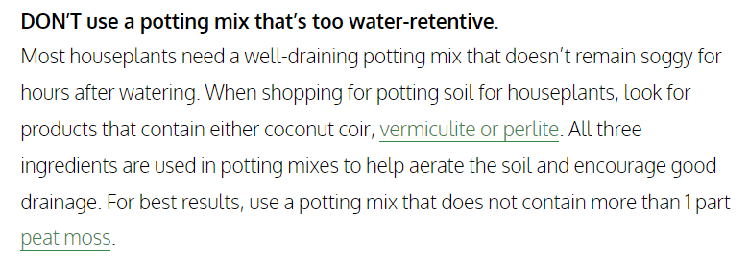

Fertilizer:

<https://www.familyhandyman.com/article/pros-and-cons-of-liquid-lawn-fertilizer/>

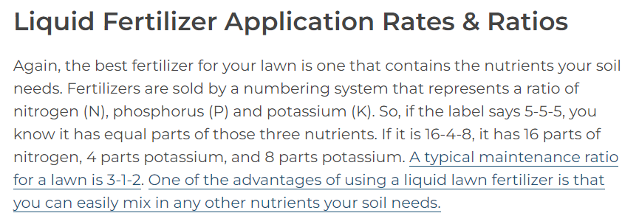

-NPK are the primary macronutrients needed by plants it appears

<https://leafyplace.com/houseplant-fertilizer-indoor-plant-fertilizers/>

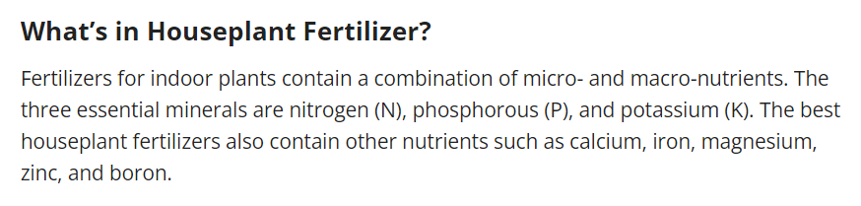

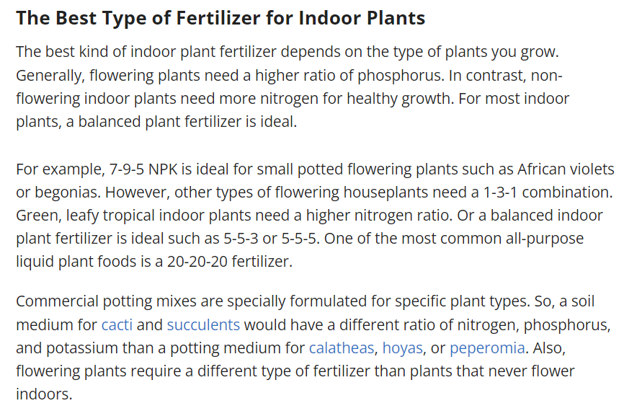

-So we probably want to split our fertilizer down into separate components of N, P, K and then depending on the plant being used, adjust ratio of dispensed fertilizer.

[Nitrogen Liquid Fertilizer](https://www.amazon.com/Lawn-Fertilizer-Simple-Solutions-Concentrated/dp/B06X9Z9MQR/ref=sr_1_1_sspa?adgrpid=1341404750667530&dib=eyJ2IjoiMSJ9.4rjpcQYX6kJx-pffU8seSFkyIW71ywILKTBmCrOXecIS6k8lBJArvYDYYXaLt7QBBvikdGehpqkbaiVNl8npq_oUqT2Z9mGTFYdzX7SbF3XJIahbvnnDyXLYfK7LxhqQEeaMilO61dkh1DwGQMWMqmEsiEJI8yZBuOnHU1Meotll8oQIc4Imh9eokRuMTBYN0GDBYZUNPi5Otdz0bX2xZn2DfW_mLjf6iy-y84F8S0t5Wy1Rah_MfAHCSABQ18rlJNALxCmooDlQfMEVk0GVzDQjm200V0XxD_4xRHpaZog.AUNtfO1HWUGSi5TU6qGp3qZQTieX2uYsIDi4Spdi2qM&dib_tag=se&hvadid=83838120353030&hvbmt=be&hvdev=c&hvlocphy=102474&hvnetw=o&hvqmt=e&hvtargid=kwd-83838144216494%3Aloc-190&hydadcr=23636_13532283&keywords=nitrogen%2Bliquid%2Bfertilizer&qid=1710779765&sr=8-1-spons&sp_csd=d2lkZ2V0TmFtZT1zcF9hdGY&th=1)

[Phosphorus Fertilizer](https://www.amazon.com/PHOSPHATE-FERTILIZER-phosphorus-fertilizer-WISTERIA/dp/B075BY4GSF/ref=sr_1_6?crid=1WY9UTPF1GHAF&dib=eyJ2IjoiMSJ9.888BLGSz8tvzNePIA3gaFBoYp6Ex2Hn1q3NDX1JmOJ8pGsed8SbB-wL3x1QziFpPSn0GmH372-SUpRK24O7ZqizSN5b0EObzM-rbmgpgHWfxuP5DreHxnPr6uGGN6UWHj1M9G4HkB1jkCMUVwY9LEaLMZJsv-xpjSINy-eVyx2BTdBUdIu5LGbZxZNvQc3WbrthIMFzX1Q_P-SqAUHqYddrsBOyPZ-y4a95OfnwJLYJt2uh1p3-iZYV0WjZL0QNHnplDwdWO98okiS_Wo31owLxoyUEsCvymhoCPH7U5EqA.uveLQd7KlMOqxKO5EnR4y8RXjWVrlmJQVU2xyKdXGtc&dib_tag=se&keywords=phosphate%2Bliquid%2Bfertilizer&qid=1710780211&sprefix=phosphate%2Bliquid%2Bfertilizer%2Caps%2C109&sr=8-6&th=1) - Not liquid :(

[Potassium Fertilizer](https://www.amazon.com/Protection-Lawn-Concentrated-Simple-Solutions/dp/B01921NUMC/ref=sr_1_1_sspa?crid=2QQ6YJ84ZGAIR&dib=eyJ2IjoiMSJ9.2CleTeZr0-0B7iEUU-6YpL7xnA7W5o1CLhd_dwE4h-t-d8GMVA_RsfkId1KGunm-vOJLBKqdAhpki-cnZ1ASWhdHnPrwM388UoMyQMqRjmJqQmqQA6IOkLu6FY3_g4YCa4a_yNWG7jOfWbEaUNw3P_qChFAgbcecRCEs2QLUzZU0ixywTzoRqV4ROyi3PD3IdqsRRq60GQ04rNGGWSM4UHBJ1UH5ERv7fIafKjA4nLxSx3ucHXYa2GUi2bj7k0k08tFA0W_c64feCn6m55O-YSQ37u-_65UWgMwgSL_mMK0.S5ji8gxZSaAtEu-Zcwax0Ya8D6BWAEMXFevCWxVkzyw&dib_tag=se&keywords=potassium%2Bliquid%2Bfertilizer&qid=1710780008&sprefix=potassium%2Bliquid%2Bfertilizer%2Caps%2C100&sr=8-1-spons&sp_csd=d2lkZ2V0TmFtZT1zcF9hdGY&th=1)

-So like conceptually it is possible to do this, but chemicals are expensive. Also we’d need a different dispensing method for a physical fertilizer. Maybe a liquid phosphorus fertilizer exists somewhere out there, so worth continuing to look.

-Or just do a liquid 1-2-1 mix and then balance it out as needed with liquid versions of the other 2 chemicals

-Actually it should be assumed that the person who bought the plant also bought the corresponding fertilizer with the correct NPK ratio for their plant.

-***Maybe we can have this info on the server to let the user know what fertilizer to buy based on their plant selection?

-Then just have 2 liquid distribution systems in the same way, but make sure the liquid fertilizer is a soil fertilizer rather than foliar fertilizer.

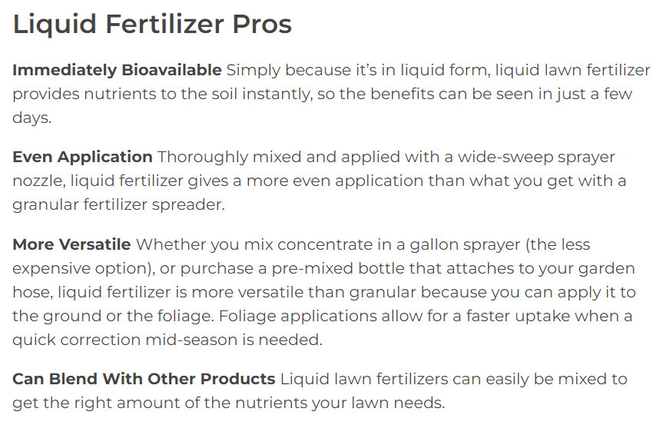

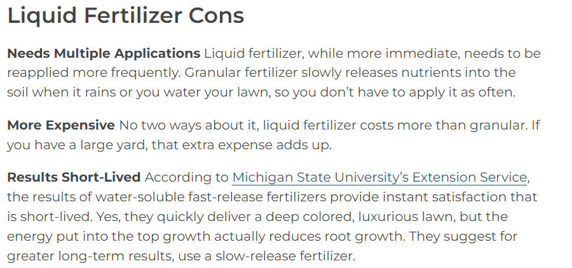

<https://plantrevolution.com/blogs/news/applying-liquid-fertilizer-what-you-need-to-know>

